Subject: MyLA311: [Service Request.Status] - [Service Request.SR Type] - [Service Request.SR Address]

Body:

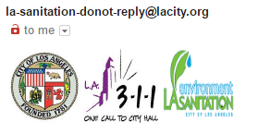

Your [Service Request] request was updated on [MM/DD/YYYY HH:MM AM/PM]. If you need further information please call the LASAN Care Center at [1 800 773-2489](tel:1%20800%20773-2489).  
  
Service Request [Service Request.SR number]

Location: [Service Request.SR Address]

Status: [Service Request.Status]  
[SR Public Friendly Message]

Recent comments:  
[Latest External Comment submitted after SR Intake]

You can check the status of your request by:

1. Visiting [https://MyLA311.lacity.org](https://myla311.lacity.org/)
2. **Using the mobile app from** [Google Play](https://play.google.com/store/apps/details?id=com.LA.MyLA311)**or the** [Apple Store](https://itunes.apple.com/us/app/myla311/id611079486)
3. **Contacting** LA Sanitation **with your service request number**

|  |
| --- |
| Email : [san.callcenter@lacity.org](mailto:san.callcenter@lacity.org)  Telephone : (800) 773-CITY  TTY : (213) 473-4112  LA Sanitation Customer Care Center is open 24 hours. |
|  |